**DATA SHARING & PROTECTION**

**Data can be shared securely in snowflake**

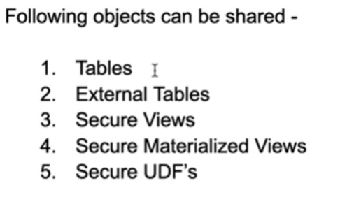

Once the data is actually shared to different accounts, It is read only i.e. the consumers who are accessing your data is only to read, they cannot change it

This is all handled by Meta data and no real data is getting transferred & it is very easy to set up

Snowflake achieves data sharing by a concept called ‘**shares’**

Here, the data provider creates and give access on it to data consumers

**Share:**

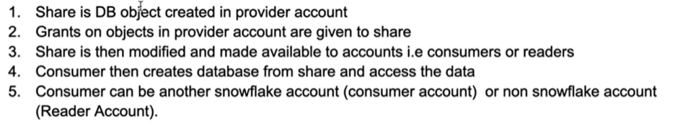

**Pictorial representation of data sharing using shares**

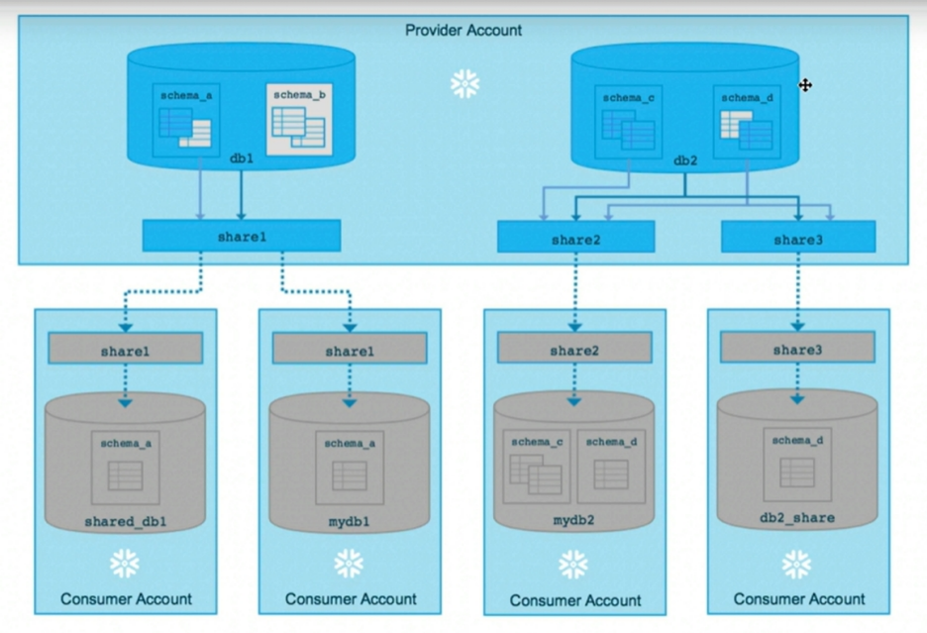

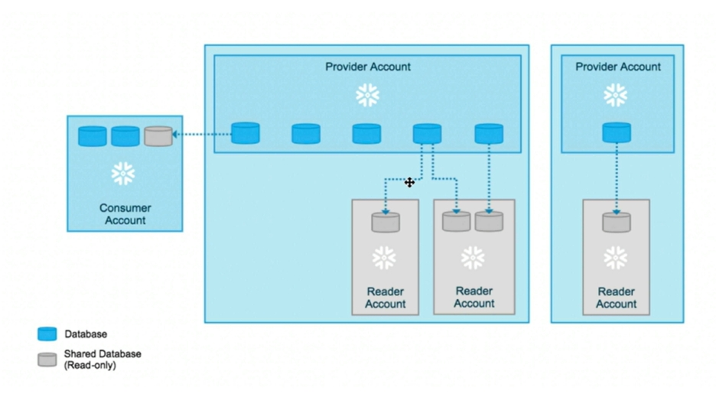

Let’s do some hands on

**So, let’s create a table, external table and UDF to be shared to reader account**

Give grants in warehouse, DB and Schema to **public**

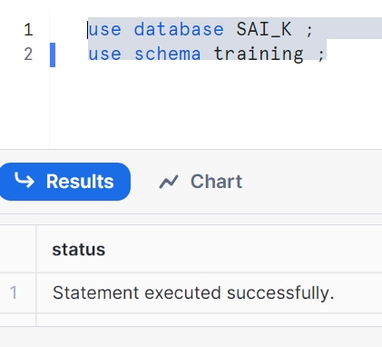

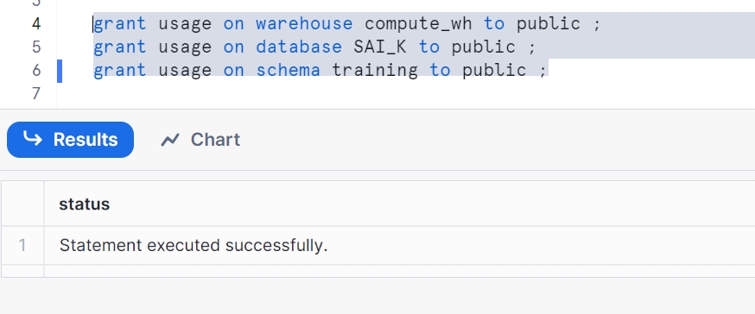

Creating an integration object

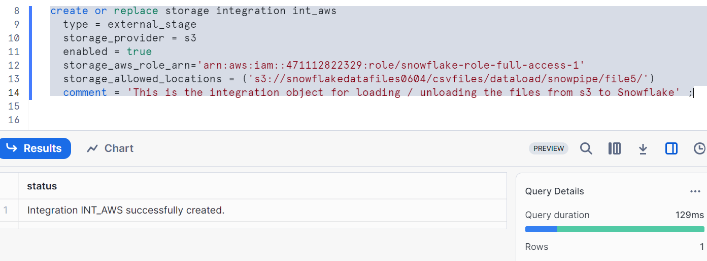

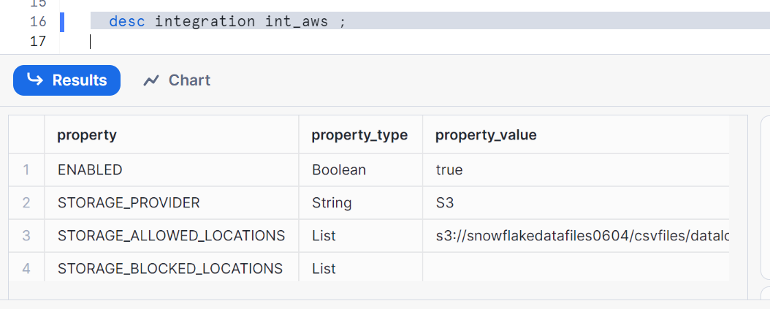

Copy the external_id and STORAGE_AWS_IAM_USER_ARN in AWS role edit trust policy and update

Creating file format

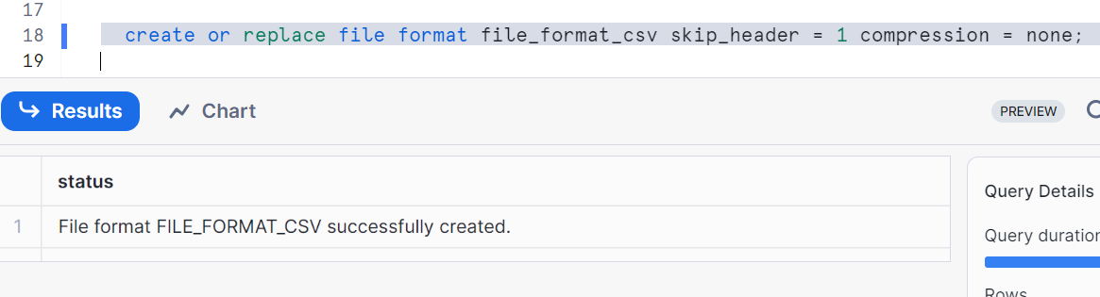

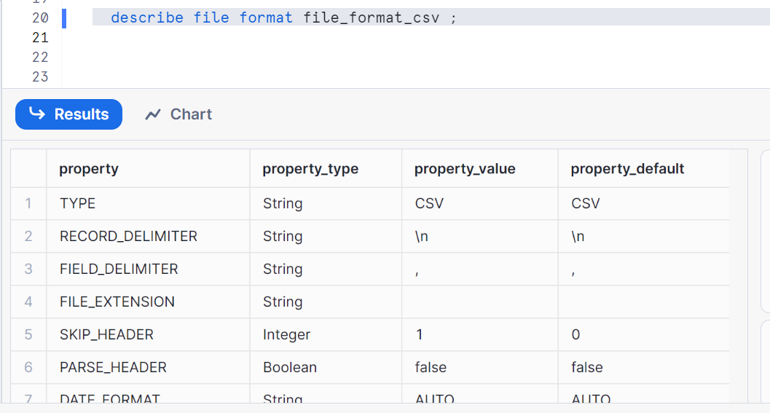

Create external stage for loading data

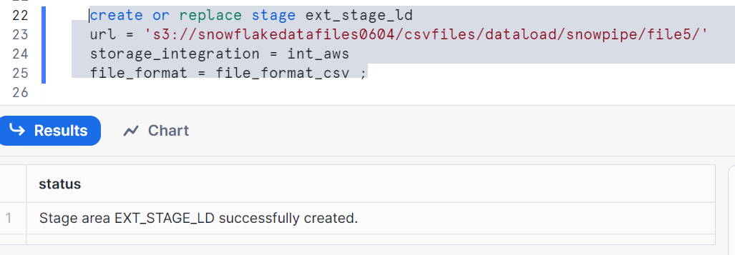

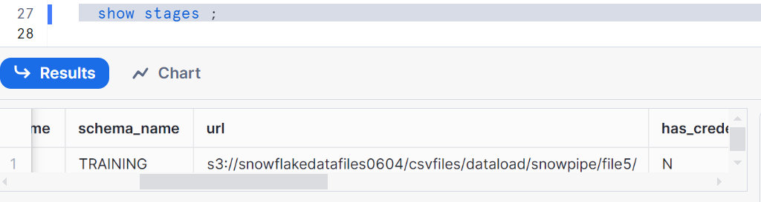

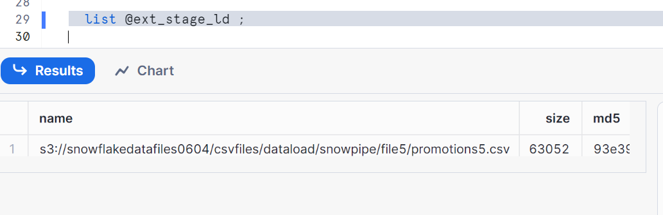

Since, I have my file promotions5 file in my S3, it is showing the same URL

Create the table to load

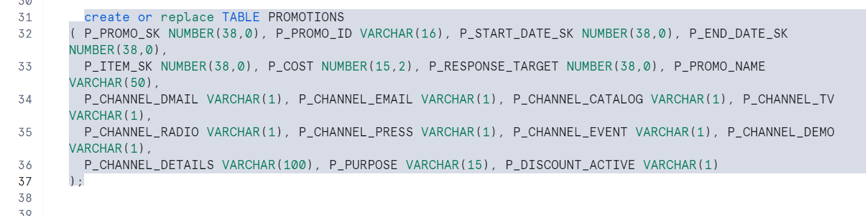

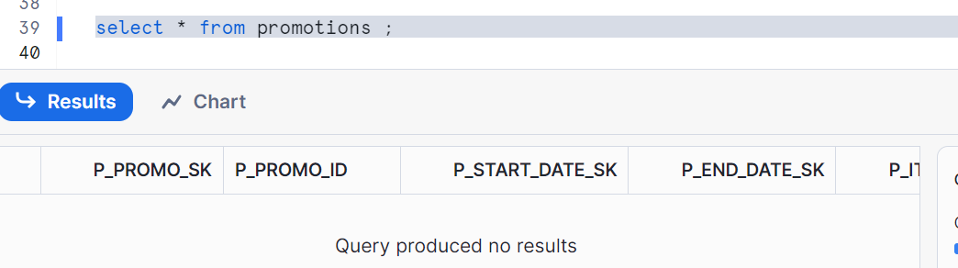

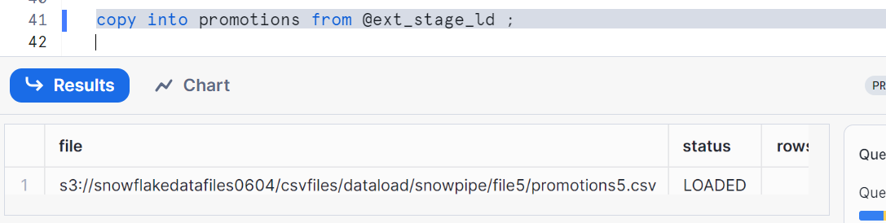

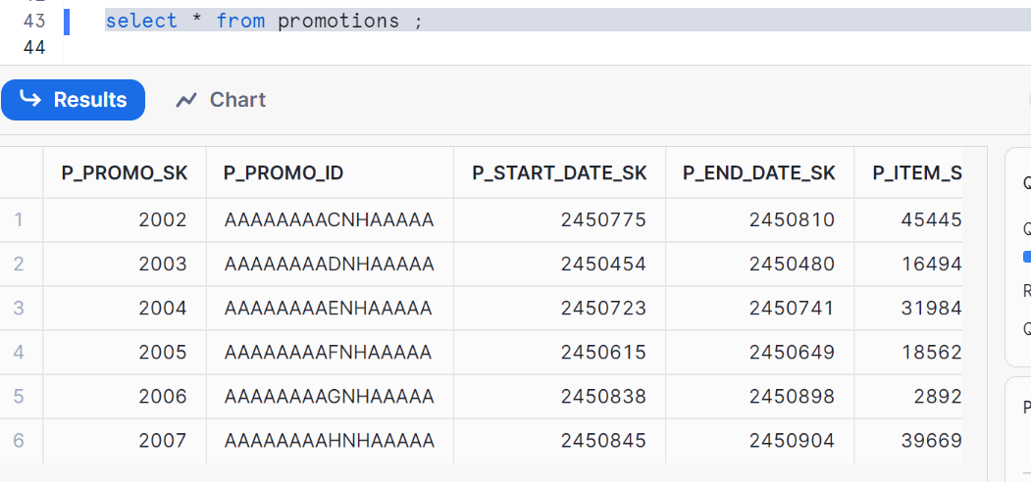

We created our table

Now, Creating an external table

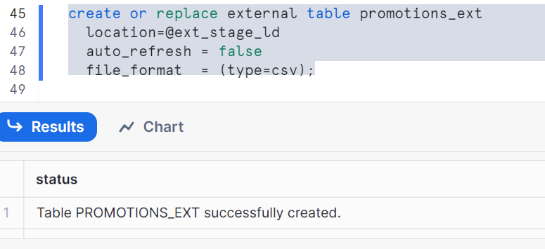

Check the data of external table

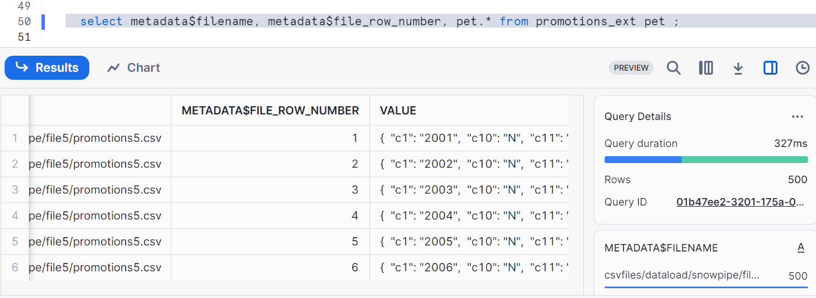

Now, creating UDF (user Defined Function)

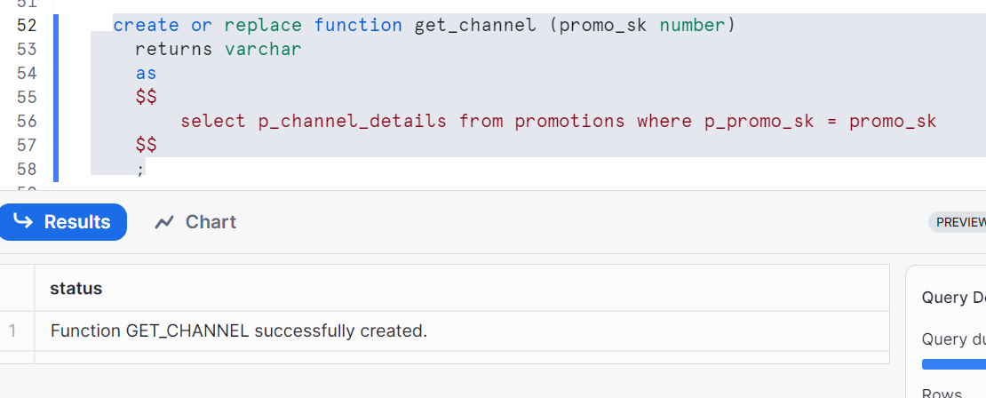

Creating data share

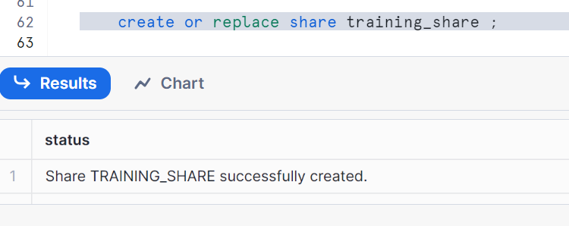

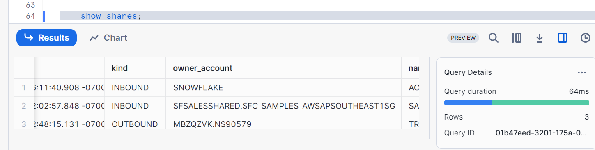

Give usage grants

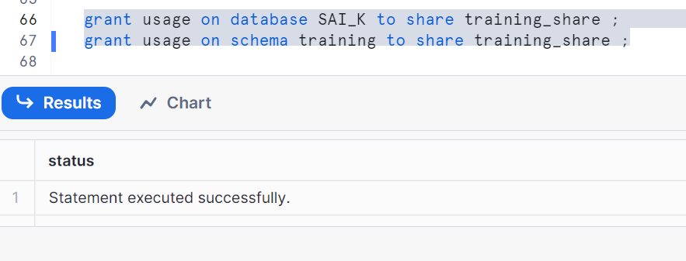

Give select grants on table

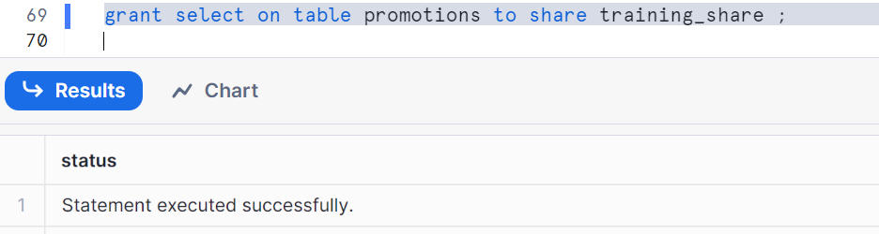

Give grants external table

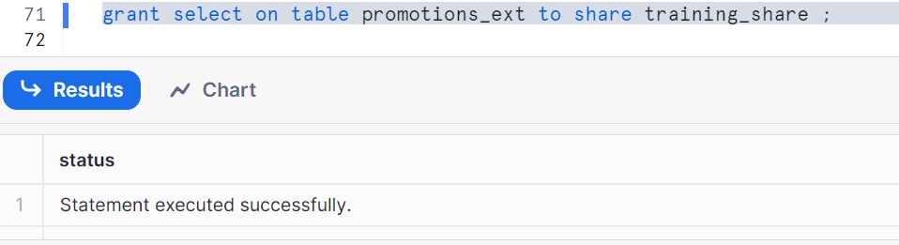

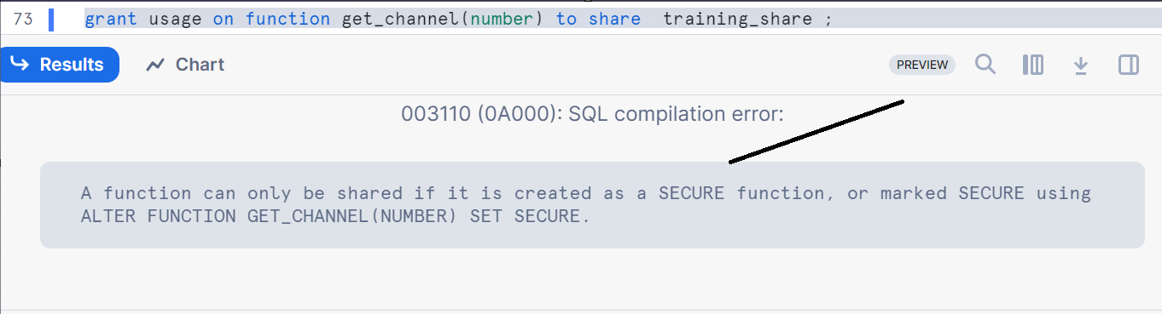

Shows error as to create a secure function

Let’s give grant for function to role public

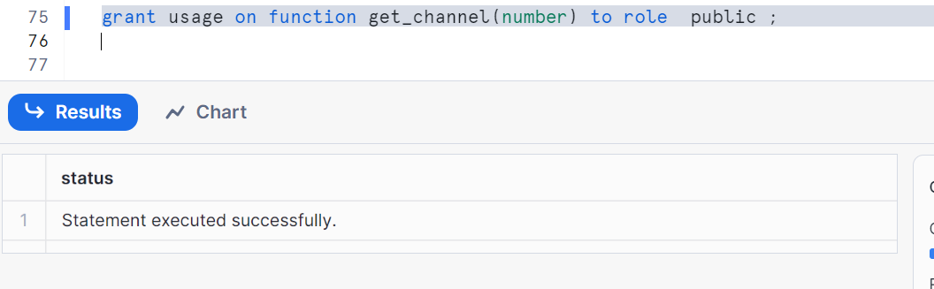

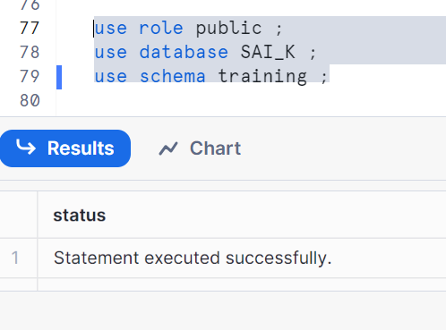

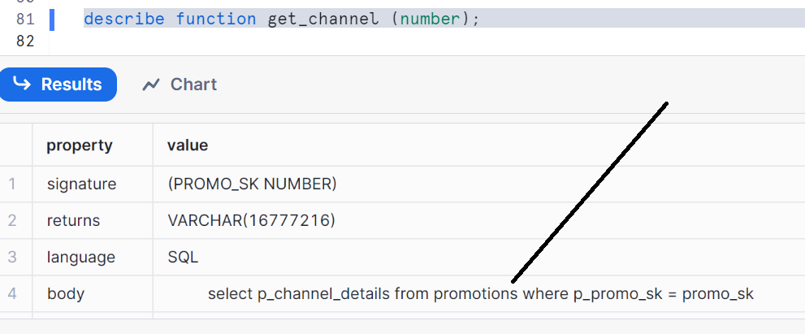

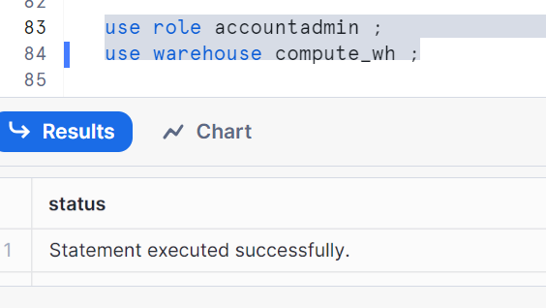

Make it secure

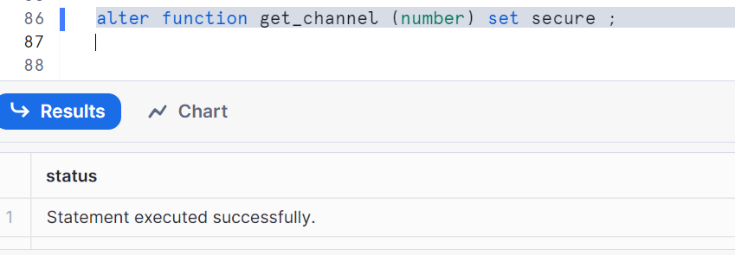



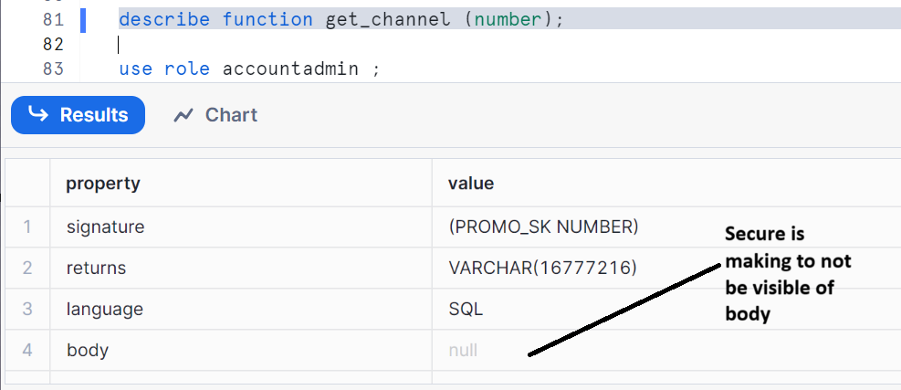

Hence, you can share your UDF with various accounts securely

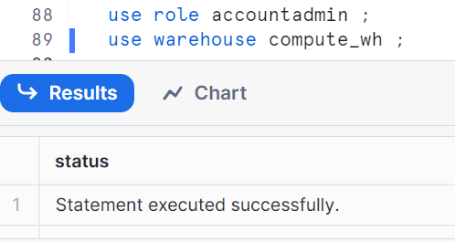

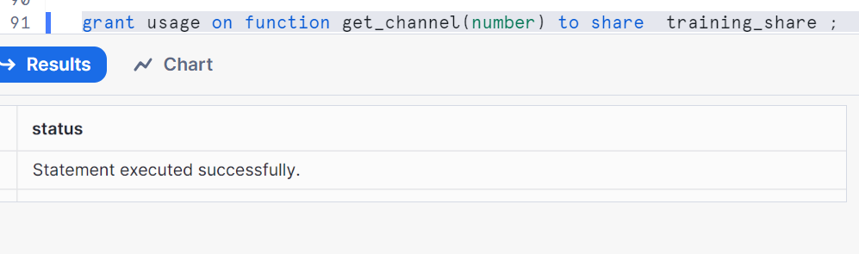

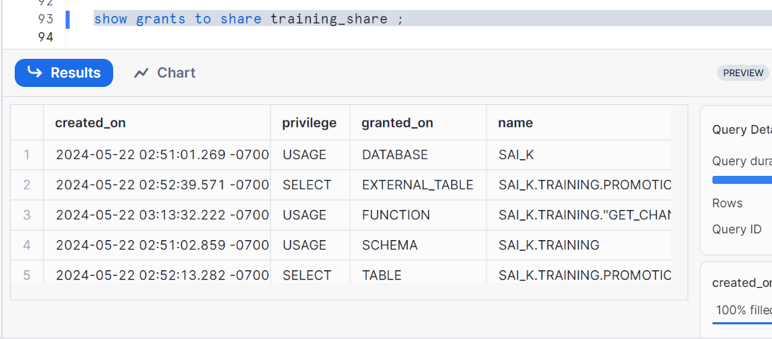

Make sure to have a reader/consumer account (to create it, go to home page in snowflake, click on data products, go to private sharing and click on reader accounts on top and create a reader account. Once it is created, copy the location URL as you can see in below image

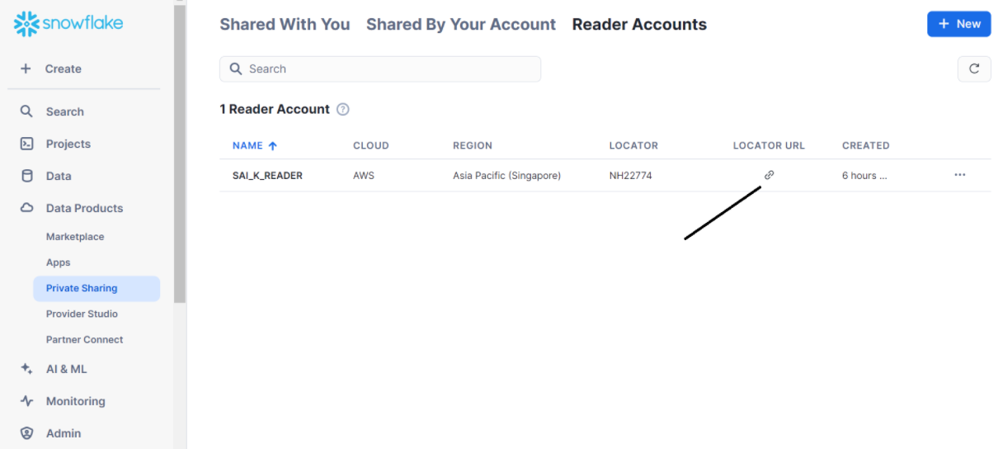

Now open the URL and give your credentials while creating reader account, now your reader/consumer account is ready

Copy Locator as shown below in your provider account (note: whatever the snowflake main account you are using is your provider account, as we are sharing the data from it)

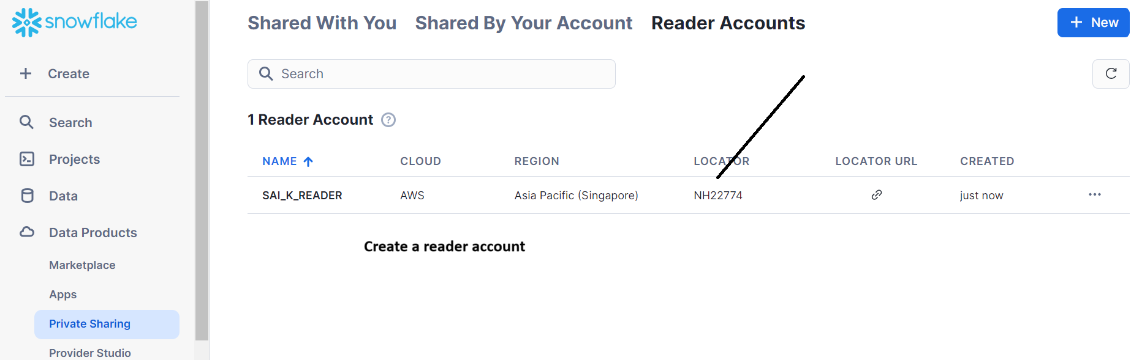

Now add account as shown in provider account with following syntax

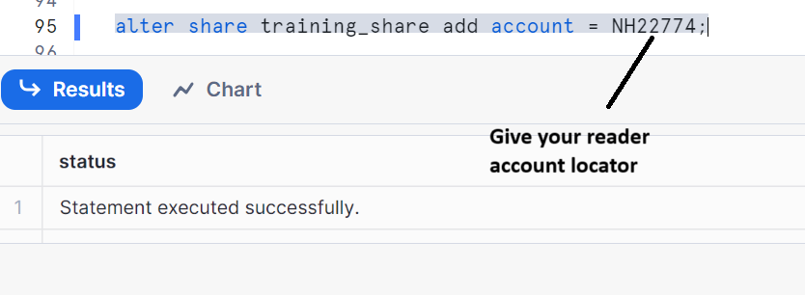

Now open your reader/consumer account worksheet and run the following

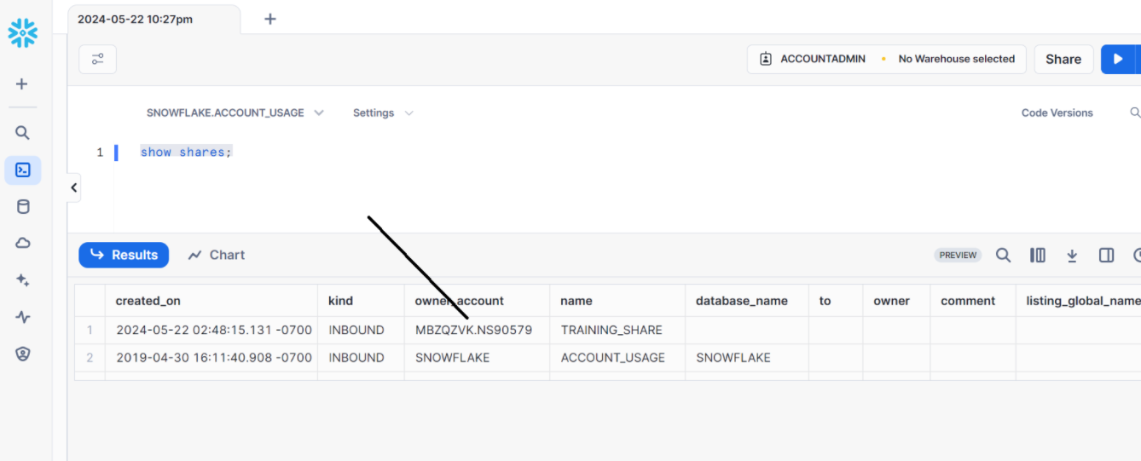

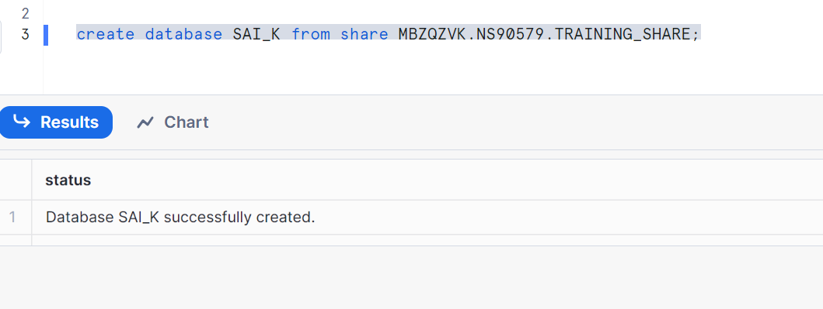

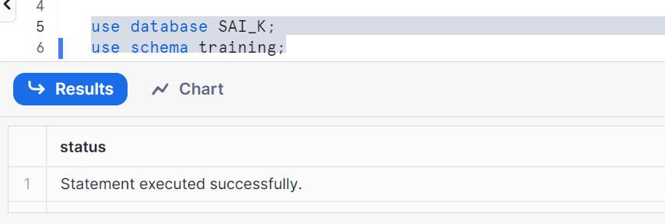

Create a warehouse and run the below

